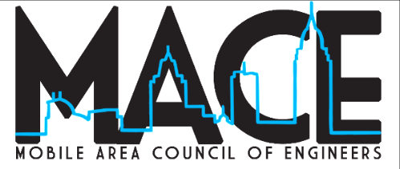

News Release
For information contact: Ashley Babb, APR
Phone: (251) 654-6347 (cell)
Email: ashley.babb@GSEeng.com
Mobile Area Council of Engineers Annual Award Recipients
Awards Banquet to be held Thursday, January 26, 2023

Mobile, Alabama (January 2023) – The Mobile Area Council of Engineers (MACE), is proud to announce its annual award recipients. MACE, a local non-profit (501c3), recognizes the success of individuals who enhance the engineering profession through their contributions to the industry, in education, and to the community. Award recipients will be recognized at the annual banquet on Thursday, January 26, 2023, at the MacQueen Alumni Center on the University of South Alabama campus. Networking will begin at 5 pm. The awards banquet will begin at 7 pm.

The award recipients are as follows:

Young Engineer of the Year: Charles William Ross Byerly, P.E. – USACE – Mobile District
Chemical Engineer of the Year: Brent D. Barnes, P.E. – Hargrove Engineers + Constructors
Civil Engineer of the Year: Natalie French, P.E. – Hargrove Engineers + Constructors
Electrical Engineer of the Year: James Dunning, P.E. – Hargrove Engineers + Constructors
Marine Engineer/Naval Architect of the Year: Spencer Johnson – Austal USA
Mechanical Engineer of the Year: Justin Thibodeaux, P.E., Gulf States Engineering, Inc. (GSE)
Engineering Manager of the Year: Robert Matthew Coaker, P.E. – Southern Earth Sciences, Inc.
Aerospace Engineer of the Year: Angel Huot - Airbus
Individual of Special Recognition: Warren H. Nicholson – N-Fina Technologies
Engineering Educator of the Year: Dr. Robert Cloutier, Professor, University of South Alabama
Society of American Military Engineers (SAME) Outstanding Engineer: Derrick Rogers, P.G.
American Society of Civil Engineers (ASCE) Outstanding Engineer: Ryan Hedlund, P.E.
MACE-Raburn Scholarship: Darian Riley, University of South Alabama Engineering
MACE-Raburn Scholarship: Laura Nguyen, University of South Alabama Engineering
About MACE
A tradition since 1967, the Mobile Area Council of Engineers (MACE) was founded by practicing engineers from the local society engineering chapters. Now, a non-profit (501c3), MACE recognizes engineering leaders in the Mobile area through an annual awards banquet. MACE also awards the MACE-Rabun scholarship to engineering students at the University of South Alabama. For more information, visit www.mobileareacouncilofengineers.com.
###

