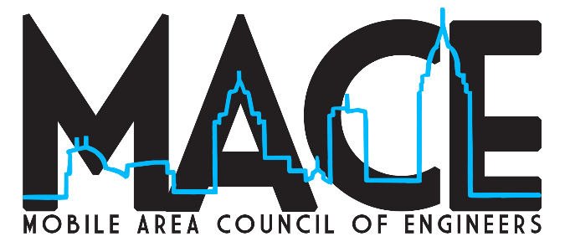

Contact: Mark Norris, MACE Chairman FOR IMMEDIATE RELEASE
Office: 251.375.7186 January 25, 2021
Cell: 251.610.4397
Email: mnorris@hargrove-epc.com

MOBILE AREA COUNCIL OF ENGINEERS (MACE)
POSTPONING INDUSTRY AWARDS PROGRAM UNTIL 2022

Mobile, Ala. – The Mobile Area Council of Engineers (MACE) announced today their annual awards program will not be held in 2021. The event recognizes outstanding service across the engineering and related disciplines, and awards two student scholarships annually.

The organization had previously postponed the awards program which typically opens the awards application process in the late fall, announces the award winners by the end of the year, and then holds a banquet recognizing the winners early the following year. “We’ve already pushed the awards entry process back once and given we are still dealing with the Pandemic we felt it prudent to postpone the event entirely for this year and refocus our events on the 2022 event,” stated MACE Chair, Mark Norris. “We didn’t want to end up in a position of completely changing the timing of our event going forward and proceeding with an event this year would put us in a position of having to ask our sponsors to support two different awards within the same calendar year.”

“While we are terribly saddened at the idea of missing a year, we recognize one of the benefits of the awards and the ceremony is the networking opportunity for our members from varied disciplines,” added MACE Awards Chair, Ray Miller. “Unfortunately, that is something that is simply hard to create in a virtual event. Therefore, our board made the difficult decision to push the entire awards process and program back.”

The application process for the 2022 awards will open in the fall of 2021 with exact dates to be announced at a later time. For more information on the awards program, past recipients, and the MACE organization, please visit www.mobileareacouncilofengineers.com.

The mission of the Mobile Area Council of Engineers (MACE) is to coordinate and promote engineering interests of the member organizations, which can best be performed by cooperative action in relation to professional, educational, civic, and social matters.

